PROJECT- WEBSITE HOST WITH AWS
Launch instance steps:
- ENTER INSTANCE NAME

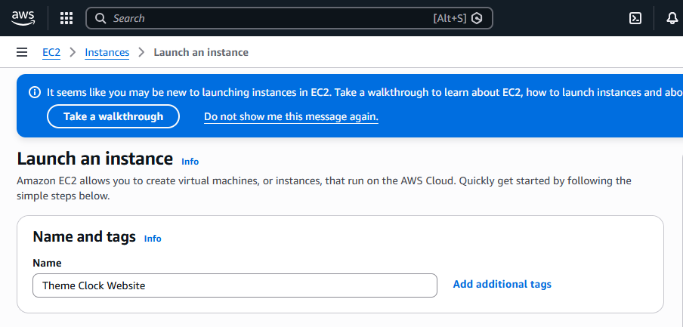
2. SELECT AMI
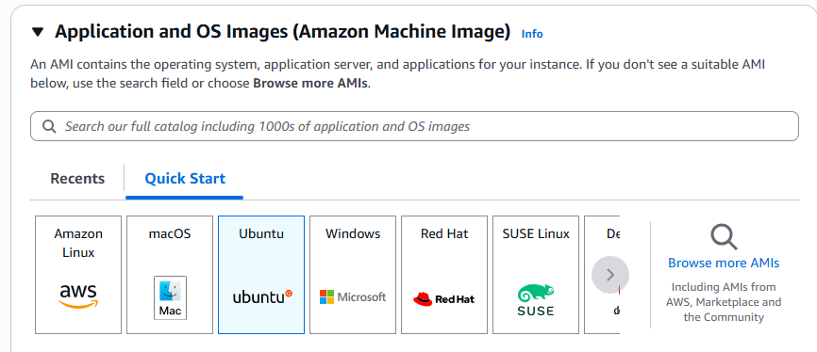

3. CHOOSE / CREATE KEY PAIR & LAUNCH INSTANCE
